

ASSIGNMENT TITLE

SQL BASIC ASSIGNMENT

Submitted By : Sachin Yadav
Course : Data Analytics With AI – September batch Live
Institude : PW Skills
Date : 10 December 2025

Q1. Create a New Database and Table for Employees

Explanation
In this task, we build a new database named company_db and create a table employees.
The table stores essential employee information such as ID, name, department, salary, and hire date.
The employee_id column is defined as a PRIMARY KEY, ensuring that each employee record is unique.

SQL Query

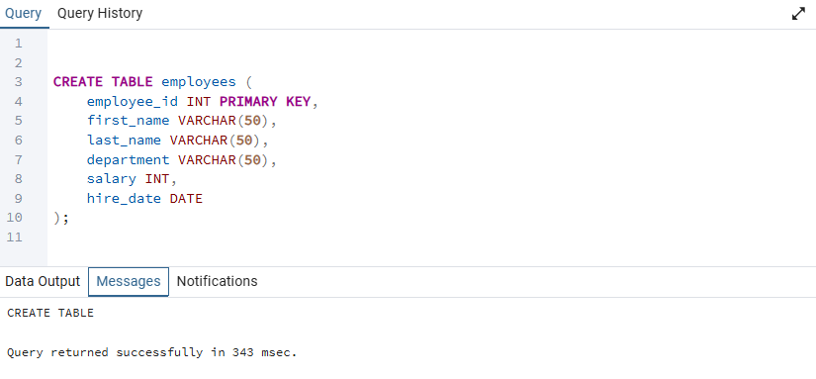

Q2. Insert Data into Employees Table

Explanation
We now insert the sample employee records as provided in the assignment. Each row represents one employee with complete details.

SQL Query
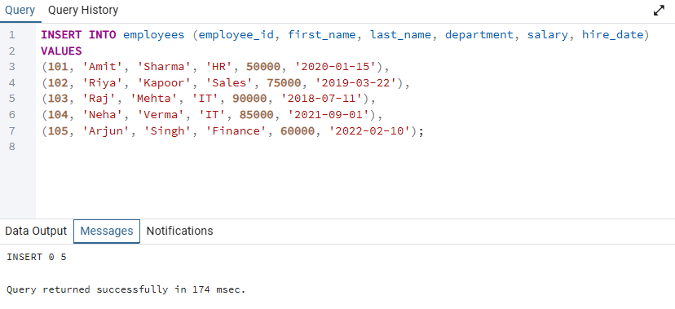
Output:
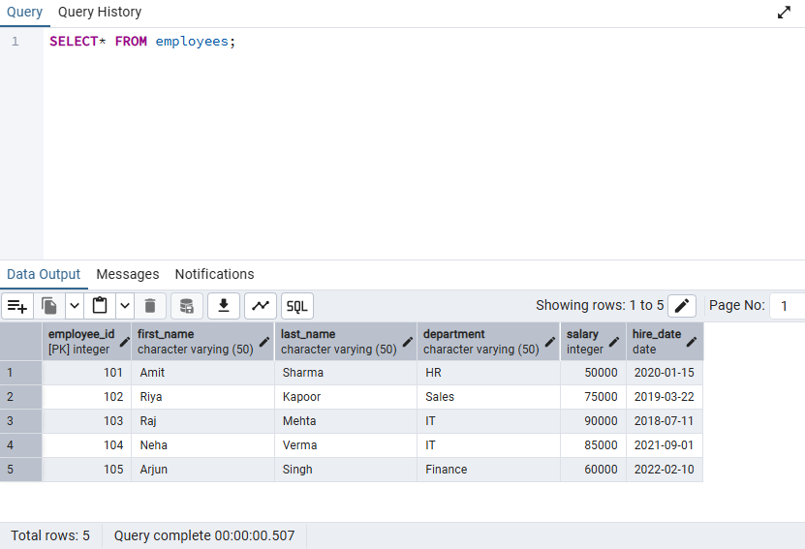

Q3. Display All Employee Records Sorted by Salary (Lowest to Highest)

Explanation
The ORDER BY clause sorts values in ascending (default) order.
Here we sort all employee records based on their salary from the lowest to the highest.

SQL Query
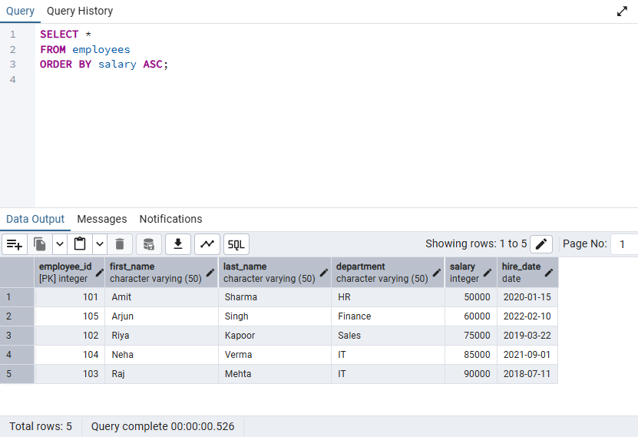

Q4. Show Employees Sorted by Department (A–Z) and Salary (High → Low)

Explanation
We apply two-level sorting:
- First by department in alphabetical order
- Then by salary in descending order

SQL Query

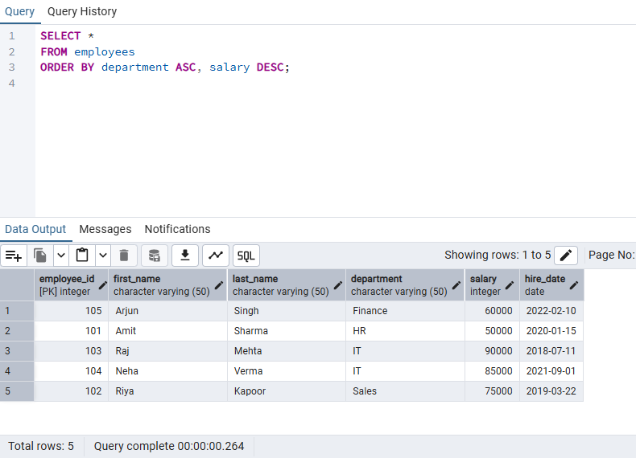

Q5. List All Employees in the IT Department, Ordered by Hire Date (Newest First)

Explanation
The WHERE clause filters only IT employees.
Sorting by hire_date DESC ensures the latest joining employees appear first.

SQL Query

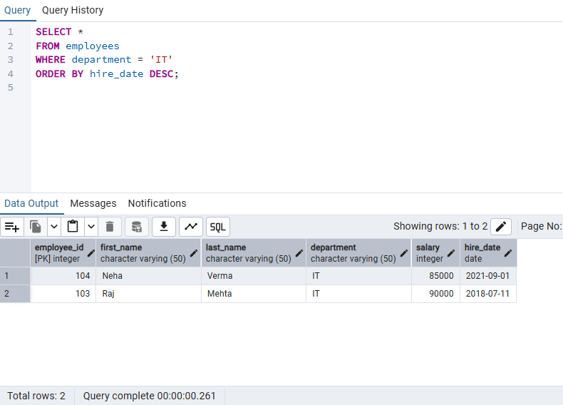

Q6. Create and Populate a Sales Table

Explanation
The sales table records each sale with a unique ID, customer name, amount, and sale date.
We then insert the given dataset into the table.

SQL Query

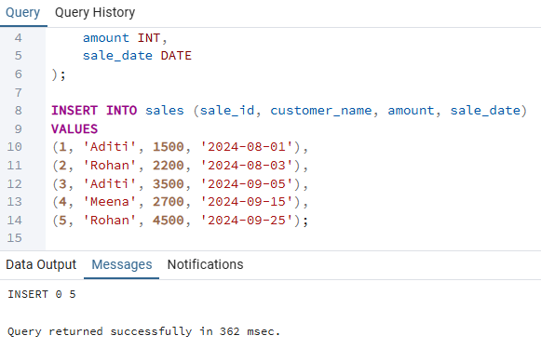

Output :

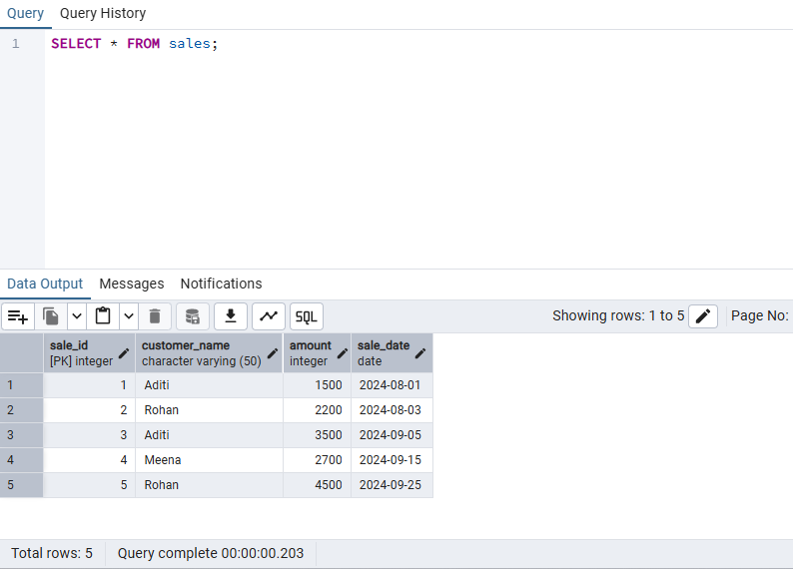

Q7. Display All Sales Records Sorted by Amount (Highest → Lowest)

Explanation
Here we sort the sales table in descending order of the amount column.

SQL Query

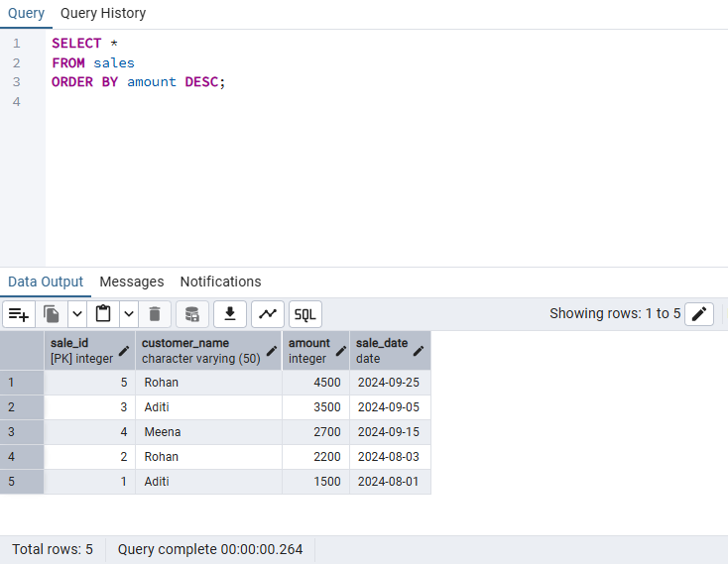

Q8. Show All Sales Made by Customer “Aditi”

Explanation
We use the WHERE clause to show only the records where the customer name is Aditi.

SQL Query

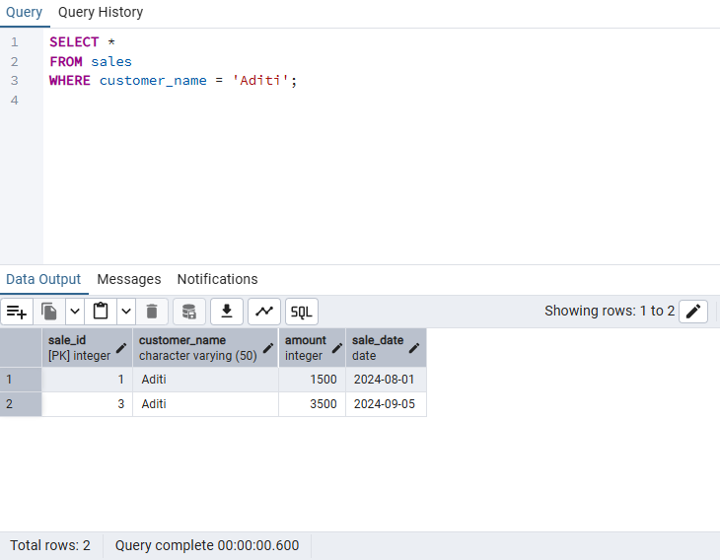

Q9. What is the Difference Between a Primary Key and a Foreign Key?

Explanation
A Primary Key and a Foreign Key are two of the most important concepts in relational database design. Although both are used to maintain accuracy and consistency of data, they serve different purposes.
A Primary Key is a column—or a set of columns—that uniquely identifies each record in a table. No two rows can share the same primary key value, and it cannot contain NULL. This ensures that every entry in the table can be distinguished without confusion. For example, in an employees table, employee_id is typically the primary key because each employee must have a unique ID.
In contrast, a Foreign Key is used to create a logical link between two tables. It is a column whose value must match an existing value of a primary key in another table. The main purpose of a foreign key is to maintain referential integrity, ensuring that relationships within the database remain valid. For instance, if a sales table contains a employee_id column that references the primary key in the employees table, the database will prevent inserting a sale record with an invalid employee ID.
In summary, a primary key uniquely identifies a row within its own table, while a foreign key connects a row to a related row in another table, thereby enforcing consistent and meaningful relationships across the database.

Q10. What Are Constraints in SQL and Why Are They Used?

Explanation
In SQL, constraints are rules that control the type of data that can be stored in a table. They act as protective conditions that prevent invalid or inconsistent data from entering the database. Constraints play a crucial role in maintaining the quality, reliability, and trustworthiness of stored information.
Constraints are used for several reasons:
1. To Ensure Data Accuracy:
For example, a NOT NULL constraint ensures that an essential field, such as employee name, cannot be left empty. This prevents incomplete records from being inserted.
2. To Enforce Uniqueness:
The UNIQUE constraint ensures that no duplicate values appear in a particular column, such as email addresses or mobile numbers. This helps avoid redundancy and maintains clean, consistent datasets.
3. To Maintain Relationships Between Tables:
The FOREIGN KEY constraint ensures that values in one table correspond to valid entries in another. This protects the logical structure of the database and avoids “orphaned records.”
4. To Define Valid Ranges or Conditions:
The CHECK constraint allows the database to enforce business rules—such as ensuring that a salary is always greater than zero. This helps maintain meaningful and realistic data.
5. To Provide Default Values:
The DEFAULT constraint automatically fills in a value when none is provided. For example, a default timestamp can be added to record when a row was created.
Overall, SQL constraints help build a strong foundation for a database by preventing errors, eliminating contradictions, and guaranteeing that the stored data follows all necessary rules. They ensure that the database remains dependable, accurate, and aligned with real-world requirements.

